Practical 05

Input:
#include <iostream>
#include <string>
using namespace std;

class Node {
public:
string page;
Node* next;

Node(string p) {
page = p;
next = nullptr;
}
};

class LinkedListStack {
private:
Node* top;

public:
LinkedListStack() {
top = nullptr;
}

bool isEmpty() {
return top == nullptr;
}

void push(string page) {
Node* newNode = new Node(page);

newNode->next = top;
top = newNode;
}

string pop() {
if (isEmpty()) {
return "Stack Underflow";
}

Node* temp = top;
string page = top->page;

top = top->next;
delete temp;

return page;
}

string peek() {
if (isEmpty()) {
return "";
}

return top->page;
}

~LinkedListStack() {
while (!isEmpty()) {
pop();
}
}
};

int main() {
LinkedListStack backStack;

string currentPage = "Home";

cout << "Visiting: " << currentPage << endl;

backStack.push(currentPage);
currentPage = "Google";
cout << "Visiting: " << currentPage << endl;

backStack.push(currentPage);
currentPage = "YouTube";
cout << "Visiting: " << currentPage << endl;

backStack.push(currentPage);
currentPage = "Wikipedia";
cout << "Visiting: " << currentPage << endl;

cout << "\nBack button pressed.\n";

backStack.pop();

currentPage = backStack.peek();

if (!currentPage.empty()) {
cout << "Current page: " << currentPage << endl;
}

cout << "\nBack button pressed.\n";

backStack.pop();

currentPage = backStack.peek();

if (!currentPage.empty()) {
cout << "Current page: " << currentPage << endl;
}

return 0;
}

Output:
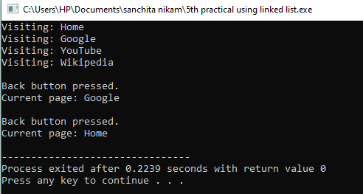

Linked list :

Input:
#include <iostream>
#include <string>
using namespace std;

class Node {
public:
string page;
Node* next;

Node(string p) {
page = p;
next = nullptr;
}
};

class LinkedListStack {
private:
Node* top;

public:
LinkedListStack() {
top = nullptr;
}

bool isEmpty() {
return top == nullptr;
}

void push(string page) {
Node* newNode = new Node(page);

newNode->next = top;
top = newNode;
}

string pop() {
if (isEmpty()) {
return "Stack Underflow";
}

Node* temp = top;
string page = top->page;

top = top->next;
delete temp;

return page;
}

string peek() {
if (isEmpty()) {
return "";
}

return top->page;
}

~LinkedListStack() {
while (!isEmpty()) {
pop();
}
}
};

int main() {
LinkedListStack backStack;

string currentPage = "Home";

cout << "Visiting: " << currentPage << endl;

backStack.push(currentPage);
currentPage = "Google";
cout << "Visiting: " << currentPage << endl;

backStack.push(currentPage);
currentPage = "YouTube";
cout << "Visiting: " << currentPage << endl;

backStack.push(currentPage);
currentPage = "Wikipedia";
cout << "Visiting: " << currentPage << endl;

cout << "\nBack button pressed.\n";

backStack.pop();

currentPage = backStack.peek();

if (!currentPage.empty()) {
cout << "Current page: " << currentPage << endl;
}

cout << "\nBack button pressed.\n";

backStack.pop();

currentPage = backStack.peek();

if (!currentPage.empty()) {
cout << "Current page: " << currentPage << endl;
}

return 0;
}

Output:

